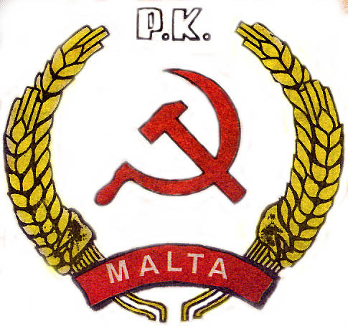

COMMUNIST PARTY OF MALTA
28/8 Vincenti Bldgs Strait Street Valletta

Dear Chairman,

Comrades,

Firstly I must give thanks to the Communist Party of Greece who has made this meeting possible. Dear Comrades my address will be short as to give more space for a healthy fraternal discussion between all of us here.
This initiative by KKE to form cooperation between the Communist Parties of member countries of the EU in order to examine more deeply European Issues, gives food for thought. This will bring a more unified approach towards the problems that working classes are facing in each and every individual European country right now .The so called Left Parties in Europe are not offering any other solution, but collaborate within the Capitalist economies instead of attempting to bring them down
Another alternative is needed. This initiative could be that alternative, that could bring about the results that we desire the end of exploitation of man by man, and strive for the creation of a Socialist society We Communists should seek further inroads towards a unified front with all other progressive forces that are willing to work with us with the framework of the objectives already stated
The Present political situation in Malta is that in March of this year General Elections, the Social Democratic Labour Party managed a Land slide Victory, after 25 years in opposition. This victory comes at a price for the Social Democrats have made inroads into the bourgeoisie Nationalist Party support by adopting neo-liberal policies.
Today the LP is more of a centrist party, shying away from its’ past progressive policies of non-alignment and neutrality and pursuing an opportunistic policy backing countries not on matter of principle but on whoever can give them the best deals, on the other hand, today they are not willing to be stigmatized as Communists.
This is alienating the grass root support of the labour Party. The Communist Party in Malta must be more active to win these workers support, as if we fail, extreme right wing parties with anti-immigration policies will win their support.
The Communist Party of Malta augurs that this initiative will be welcomed by most of the fraternal parties gathered here, and a consensus will be reached for the good of the movement

Thank You.

